Tree Management Statements

September 2023
Contents
Introduction 3
1.1 Structure of the Tree Management Statements 3
1.2 How is the ECC Estate broken up? 3

Whole Essex County Council Estate Tree Management Statement 5
2.1 General tree management statements 5
2.1.1 Site surveys and recording inspections 5
2.1.2 Prioritisation of tree works 11
2.1.3 Undertaking tree works 12
2.1.4 Refusal of tree works 13
2.1.5 Constraints on tree works 15
2.1.6 Malicious damage 18
2.2 Insurance claim tree management statements 18
2.3 Pest and disease tree management statements 21

Highways and Built Estate Tree Management Statements 23
3.1 Highways tree management statements 23
3.1.1 Highways Responsibilities 23
3.1.2 Reactive inspections 24
3.1.3 Commercial bus routes 24
3.1.4 Clearance from the Highway 25
3.1.5 Private trees 26
3.1.6 Utilities and overhead cables 26
3.1.7 Vehicle crossovers 27
3.1.8 Tree planting 28
3.1.9 Trees on new developments 30
3.2 School tree management statements …32
3.3 Essex Properties and Facilities tree management statements 33

Rural Estate Tree Management Statements 34
4.1 Country Park tree management statements 34
4.1.1 Retention of deadwood 34
4.1.2 Veteran trees 35
4.1.3 Woodland Management 37
4.2 New Woodlands 37
4.3 The Rural Estate 38

Glossary 39

Legislation and Legal Cases 41

Guidance and References 43

- Introduction
Essex County Council (ECC/The Council) recognises it has a responsibility to manage and maintain all trees within its estate and, on occasion, trees outside of its estate. It also has an ambition to increase the number of new trees in the ECC estate to maximise the canopy cover and multiple benefits the trees provide.

The trees within the estate are a vital resource in helping to achieve ECC’s ambition of the county reaching net zero by 2050 – a recommendation made by the Essex Climate Action Commission. There are multiple other benefits created by trees, such as improved biodiversity, shade, urban street cooling, flood reduction, amenity, economic uplift etc and so there must be balance between management and enhancing the asset.

The Tree Management Statements reflect the Vision, Aim and Objectives set out in the Tree Plan.

The statements in this document outline how the trees within the management of ECC and the opportunities for new trees will be managed to balance the responsibility of the Council to safely maintain its tree stock, whilst enhancing the benefits trees bring to aid in achieving Net Zero and multiple benefits.

1.1 Structure of the Tree Management Statements
2. Whole Essex County Council Estate Tree Management Statements

- General tree management statements
- Insurance claim tree management statements
- Pests and diseases tree management statements
3. Highways and Built Estate Tree Management Statements

- Highway tree management statements
- EPF tree management narrative
- School tree management statements

4. Rural Estate Tree Management Statements
- Country Park tree management statements
- Woodlands statements

1.2 How is the Essex County Council estate broken up?
ECC own or control the vast majority of the roads, streets and much of the public realm in Essex, from the A road verges and country lanes, to town and city streets. On those verges and roads, ECC owns thousands of trees in all different growth stages. ECC also owns a substantial estate of buildings, including but not limited to: ECC Offices, Schools, Libraries, Adult Community Learning Centres, Nurseries and Youth centres etc. These buildings are generally set in urban areas and around these buildings are car parks, green infrastructure, and substantial tree numbers.

In the rural areas, ECC is still a large landowner, owning 755 hectares of Country Parks, which includes a large percentage of woodland. It also owns 130 hectares of other woodland, four Outdoor Pursuits Centres and 412 hectares of rural estate. In recent years, the Essex Forest Initiative has planted 40,250 young trees on two new ECC sites covering 14 hectare and 11,807 trees on ECC Country parks.

Essex Housing Development LLP do have some short-term responsibility for trees within their ownership as land transitions to development stage. However, due to the short term of this ownership, trees within their sites will not be included under the same management as outlined in this document. This is the same with Essex Cares Ltd which, although owned by the Council, is managed outside of the Council assets.

Statements will be relevant for all directorates within ECC, however, there will be instances where individual management statements are required. In the case of Highways, the network will be split into roads for the purposes of inspections, which will be referred to as ‘sites’ hereafter.

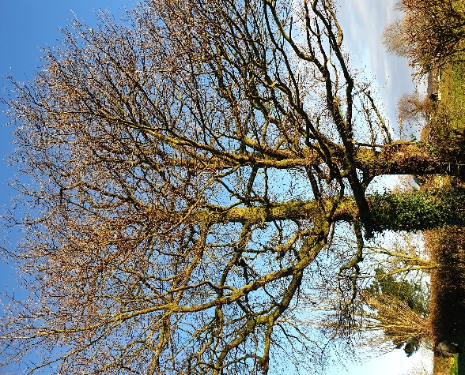
Example of a tree located adjacent to the public highway

- Whole Essex County Council Estate Tree Management Statements
This section covers general management statements, insurance statements and pest and disease issues covering all trees on the ECC estate.

2.1 General tree management statements
Essex County Council aims to improve the quality and impact of its tree stock both by good management of existing trees and strategic planting of new trees to enhance the canopy cover and the multiple benefits provided by a diverse tree population.

Under the Health and Safety at Work Act (1974), The Highways Act (1980) and Occupiers Liability Act (1984), and under common law, the Council has varying duties to prevent harm to people and property and to abate a legal nuisance. The Council has an obligation to comply with specific legislative requirements such as Tree Preservation Orders, save in relation to specified circumstances relating to dangerous or dying trees or existing or new/improved highway works (Schedule 1 of the Highways Act 1980).

It is recognised that a balance must be struck between retaining trees where possible and mitigating the risk of harm/damage. For this reason, work will normally be carried out in accordance with the following statements which comprise the General Management Statements.

2.1.1 Site Survey and recording inspections
To manage the duty of care, the Council has an obligation to ensure the safety of its tree stock. This inspection regime will be updated as required throughout the duration of the Tree Management Plan, dependant on new case law that emerges.

Industry guidance focuses on good risk management and the general principles outlined in the National Tree Safety Group’s ‘Common sense risk management of trees’ (2011) focuses on finding balance between the value of trees and public safety. These are as follows:

- Trees provide a wide variety of benefits to society
- Trees are living organisms and naturally lose branches or fall
- The risk to human safety is extremely low
- Tree owners have a legal duty of care; and
- Tree owners should take a balanced and proportionate approach to tree safety management

The Council will ensure site surveys based on a three-year cycle, however, where a mature tree or tree with a known defect poses an unacceptable risk, inspections will be scheduled more frequently in line with the risk posed (Cavanagh v Whitley Parish Council [2018]). All site inspections will be recorded on the Council’s tree management system (Ezytreev©). Previous inspections, although not currently transferable to the new system, will be retained on file.

All officers that will be carrying out surveys will be trained for their role and will be competent in tree inspection. All those carrying out inspections will either have or be working towards, a qualification in Professional Tree Inspection.

There are four levels of tree inspection:

Site survey – A visual assessment as part of a survey looking for significant and prominent hazards posed by the trees on a site.

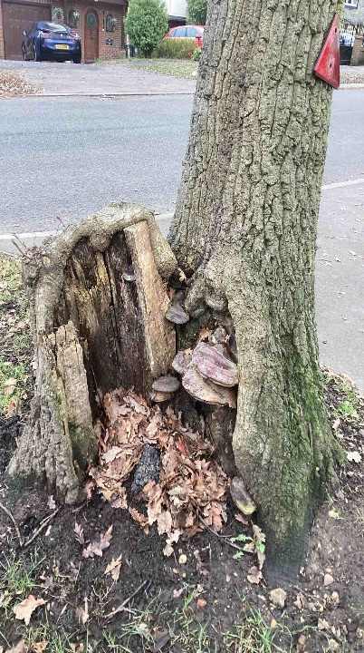
Tree located on the public highway with significant basal decay and fungal fruiting bodies
Basic inspection – A visual assessment of an individual tree where the site survey is insufficient to determine whether the Council should consider action. It will consider the structural integrity of the tree and will be based upon a visual inspection from ground level using only basic equipment, such as a mallet, probe, and binoculars. If action is not required and the inspection frequency is in line with the remainder of the site, the basic inspection will not be recorded.

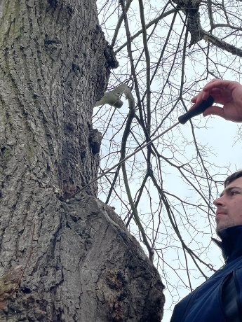
A member of the Arboricultural team undertaking a basic tree inspection

Detailed inspection – A systematic approach to tree inspection where results are recorded. The aim is to obtain a sufficient understanding of the condition of the tree (physiological and structural) to inform any potential resulting works and the reinspection frequency. The results will be recorded on the Council’s tree management system.

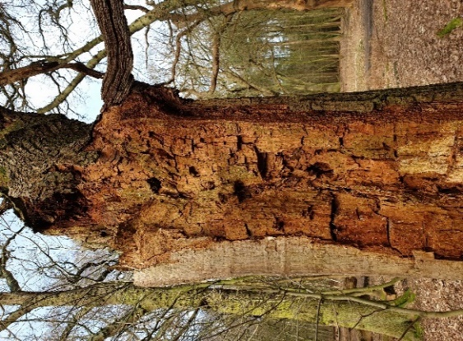
An example of a tree in a woodland where detailed inspection would be used to assess whether works would be required

Advanced inspection – Specialist equipment or inspection techniques will be used in combination with a detailed inspection to gain an understanding of the structural integrity of certain parts of the tree that cannot be identified from a detailed inspection. It may include a climbing inspection or decay detection and all results will be recorded in addition to the detailed inspection notes.

The Arboricultural team may also utilise other data systems being used by other departments to inform whether an inspection might be necessary. They will be used only where appropriate and will not form the sole method of assessment where the need for a site survey has been identified. Arrangements will be made to share inspection information with the relevant departments.

Site survey dates will be recorded on the tree management system. Details of basic inspections carried out on individual trees will not be recorded and so the site survey date will act as a record of previous visits. If no record is held for an individual tree/tree group, it can be assumed that no significant defects were visible at the time of the previous survey and that individual trees should be reinspected in line with the remainder of the site at the next survey. This does not apply if a detailed inspection or advanced inspection was carried out.

The details recorded for site surveys or basic inspections will be as follows:

- Date of inspection
- Name(s) of person undertaking the inspection
- Site inspected
- Any significant defects noted
- Any limitations preventing full inspections
- Species present
- Any action recommended
- Due date of next inspection.

Details of all detailed and advanced inspections will be recorded on the system. All inspections will initially be a site survey and/or basic tree inspection, progressing to a detailed or advanced survey where there is a potential risk or a need for tree work has been identified. Where a detailed or advanced inspection is carried out on an individual tree/tree group, the following details will be recorded:

- Date of inspection
- Name of person undertaking the inspection
- Tree number
- Species name
- Age class
- Physiological condition
- Structural condition
- Defects present that pose a risk other than a minor insignificant risk
- Limitations preventing full inspection
- Recommendations
- Due date of next inspection.

These inspections will be carried out in line with Service Level Agreements between Place Services and the relevant Council directorate.

Reactive inspections will be carried out as required. These will result from enquiries or other communications generated by members of the public, adjacent property owners, other bodies or directorates within the Council. Where a recent site survey has been undertaken, subsequent visits will not be undertaken unless there are circumstances suggesting that the condition of an individual tree may have declined, otherwise a response will be provided based on the latest site survey results. Where there are circumstances suggesting that the condition of a tree may have declined or there has been an event where impact may have occurred, an additional inspection will be scheduled and carried out. These reactive inspections will be carried out in line with Service Level Agreements between Place Services and the relevant Council directorate.

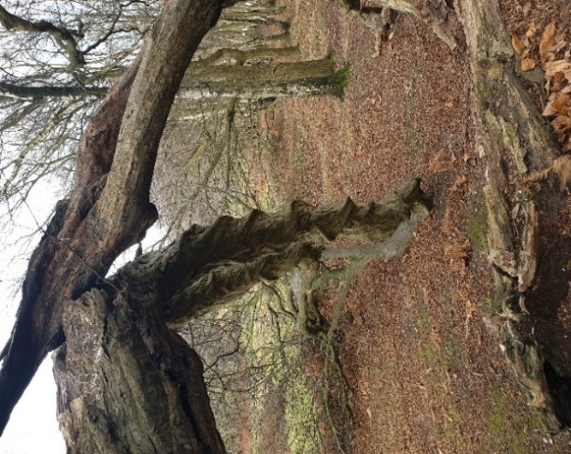
An example of tree failure identified during routine inspection
STATEMENT GM1: The Council will balance the risk and benefits of trees through good tree management to ensure that risks of injury/damage to people and property are as low as reasonably practicable. This will be achieved using the methods outlined in this document.

STATEMENT GM2: The Council will aim to carry out inspections at a minimum of every three years and inspections will be recorded on a tree management system. All staff carrying out surveys will be competent.

STATEMENT GM3: Individual tree inspections will be recorded where trees either require remedial works to make them safe or ensure longevity or where a tree requires more frequent ongoing inspection.

2.1.2 Prioritisation of tree works
Where a site survey has been undertaken and a detailed/advanced inspection has been carried out, tree works may be recommended. These may include, but are not limited to:

- Crown reductions
- Crown lifting
- Crown thinning
- Pollarding
- Re-pollarding
- Deadwood removal
- Ivy removal
- Selective limb removal
- Removal of basal growth
- Felling
- Stump grinding

Tree works resulting from inspections shall be carried out in accordance with the priority given. Work priorities have been developed in line with the National Tree Safety Group’s ‘Common sense risk management of trees’ (2011) and principles included in LANTRA’s Tree Inspection qualification. The decision on the priority would be based on the condition of the individual tree, its location, and the risk it poses to users in the vicinity. The officer inspecting will use these principles, as well as their knowledge and competency, to give a timescale commensurate with the risk posed.

Those trees with the most significant current risk will be prioritised over works that are considered to be routine/of low importance. Unless there are exceptional circumstances, the following time scales will be adhered to:

- Urgent – works required immediately to make the tree safe
- Very high – works required within 30 days
- High – works required within 90 days
- Moderate – works required as part of scheduled maintenance over 12 months from the date of inspection; and
- Low – works of the lowest priority and may be done if budget allows and in accordance with the budget timescales

Where a tree is to be retained but requires a cyclical maintenance regime, it will be recorded on the tree management system but might not require inspection prior to work. Ongoing/repeat maintenance will be considered in the following scenarios:

- Where a tree has been identified as a cause (rather than potential cause) of damage, but reduction works/pollarding are deemed sufficient to prevent foreseeable future damage
- Where it is foreseeable that a tree may cause damage if left unmanaged
- Where there is a defect within the tree that requires repeat works to reduce the likelihood of failure; and
- Where the tree has been subject to past management by the Council, irrespective of the reasoning
STATEMENT GM4: The Council will carry out identified tree works on a priority basis that will be commensurate with the risk posed as identified by an inspection.

STATEMENT GM5: Cyclical maintenance will be carried out only where it is deemed necessary and will be noted on the tree management system.

2.1.3 Undertaking tree works
All resulting works identified following the above steps will be carried out through suitably qualified Council staff or contractors.

Trees can be permanently damaged as a result of poor workmanship and this damage may increase future maintenance needs and costs. The scale of the work, skill of the contractor and health of the tree are among some of the factors that can affect future condition.

Arboricultural contractors require specialist knowledge and skills to properly undertake maintenance work. Contractors should have appropriately trained and qualified staff, the correct equipment with maintenance records, a trained person to undertake risk assessments, a staff training programme and a stated Health and Safety strategy. This is in addition to the financial and insurance requirements of contracting with the Council.

The Council will only use contractors on an approved contractor list, which is managed by the Arboricultural team. This is the system currently in operation. The work of Arboricultural contractors will be monitored where there is a requirement for this, to ensure that their workmanship, health and safety performance and competency meet required standards. To formally monitor these standards, the following will be observed:

- Insurance documents, health and safety policies, as well as competency certificates will be requested annually. Failure to provide these, or failure to provide them to an adequate standard, will result in a short period being given to remedy the situation, whereby failure to do so will result in the removal of the contractor from the approved contractor list.
- Audits will be carried out on each contractor at a minimum of twice a year. This could include an unannounced visit to site, requesting copies of risk assessments and/or monitoring the quality of work that has been carried out. The records of these documents will be kept on file by the Council for each contractor to ensure an auditable trail.

Where Council staff are used to carry out works, the same audit trail will be applicable and risk assessments will be retained for every job completed. As the workload will be managed through the tree management system, all on-site documents will be retained on each piece of site work allocated. The health and safety documents will all be kept on the Council’s internal drives.
STATEMENT GM6: The Council will use competent contractors to carry out tree work and will aim to monitor them twice annually to ensure standards are met or use its own officers.

2.1.4 Refusal of tree works
Work to trees will only be carried out if it is for sound Arboricultural reasoning and is within the scope of this Plan to do so. It is not expected that the Council will be doing work which falls within the following categories:

- Seasonal nuisance (leaf fall, seed drop, fruit litter and honeydew deposition)
- Shading, obstruction of view and branch overhang
- Interference with television signal/satellite reception
- Perception that a tree is too large, or that it might cause damage in the future
- Disruption to pathways and roads where alternative solutions can be undertaken cost effectively, including undertaken by a third party

‘Seasonal nuisance’ can be difficult to define. Screening by trees may be acceptable to one person, but shading caused by the same trees may not be acceptable to the next-door neighbour. Long term solutions for such perceived problems are difficult, if not impossible, to remedy, short of removing a tree. With many tree species, problems can be exacerbated or worsened by pruning works e.g., the shading from subsequent denser regrowth can be worse than shading prior to pruning.

There is no general legal requirement for the owner of a tree to carry out works to abate this type of nuisance. Activities such as clearing up fallen leaves or seeds are seasonal phenomena and are seen as normal household maintenance operations and, while they clearly are a burden to some people, they are just a fact of neighbourly life, particularly when weighed against the multiple benefits that trees provide to the environment and the wider community.

In common law, the owner of an adjacent property is entitled to prune back to their boundary line, providing that the tree does not have statutory protection (Tree Preservation Order/Conservation Area protection) and that the tree’s health is not damaged long term because of the work.

The Council does not undertake pruning for the facilitation of light to solar panels unless the pruning required is sympathetic, would not require repeat maintenance and can be funded by the private individual in question.

Certain types of nuisances fall into the category of legal nuisance and the owner of a tree must, if advised of the nuisance or the likelihood of a nuisance developing, take steps to abate the nuisance. The problems associated with root damage fall into this category. In such situations, and once a tree has been implicated as a legal nuisance, remedial work can be carried out in due course. This may include, but is not limited to, the following actions:

- Crown reductions
- Crown lifting
- Pollarding
- Re-pollarding
- Selective limb removal
- Removal of basal growth
- Felling
- Stump grinding
- Root barrier installation

Certain types of pruning such as crown thins, pollards and crown reductions can lead to long term management requirements and will only be carried out where there is no other suitable alternative. Topping, or reducing the height of the tree, will never be carried out as it is bad practice and will reduce the structural integrity of the tree. Works will only be carried out where it is in line with best practice and in line with recommendations made in BS3998: 2010 Tree Work. Recommendations (BSI, 2010) or its successor guidance.
The Council will therefore prioritise its legal obligation in relation to safety/abating legal nuisances over all other aspects of general maintenance or contribution to the local environment.
STATEMENT GM7: The Council will refuse works that are not a legal requirement and will prioritise tree works that are in the interest of public safety and/or in abating a legal nuisance.

2.1.5 Constraints on tree works
There are instances where there are constraints on carrying out tree work.

Under the Town and Country Planning Act (1990) and the Town and Country Planning (Tree Preservation) (England) Regulations (2012) it is an offence for anyone to;

- cut down
- top
- lop
- uproot
- wilfully damage
- wilfully destroy

“Any tree to which an order related or cause or permit the carrying out of any activities mentioned above, except with the written consent (subject to conditions) from the local planning authority”. As the Council is a local highway authority, it does not hold details on such Orders and is not permitted to undertake works to protected trees without such consent in many (but not all) circumstances. As such, the Council is beholden to the timescales set out in the Act and must respect such timescales, as any other tree owner of a tree preservation order tree (TPO tree) would. As a highway authority, there are some alterations to the requirement for permission for protected trees.

Where a highway order or scheme has been confirmed by the Secretary of State for Transport under Schedule 1 of the Highways Act (1980), consent is not required for cutting down, topping, lopping, or uprooting a tree protected by an Order to implement the scheme.

The case of R (on the application of Dillner) v Sheffield City Council [2016] Env. L.R. 31 addresses the balance of the highway duty to repair against tree protections in particular. It states that where works are required to be carried out to trees, i.e., under the ambit of ‘repair’ to protect the safety of persons using the highway to pass and repass, they are permitted to do so without consent. The case particularly refers to consent in conservation areas (paragraph 168 of the judgement).

Paragraph 29 of the judgement highlights s58(2) Highways Act 1980 (Special defences to highway authority for failing to maintain) does not provide a defence that removal of the danger would harm the visual appearance of the highway in question. That reflects a point of importance in these proceedings. These streets are highways, and the starting point for considering whether a tree within a highway should be retained or removed is its effect or otherwise on the role of that street as a highway – i.e., to facilitate passage and repassage, not to facilitate the creation, preservation, or enhancement of an attractive environment.

Where TPO works required are urgent, a five-day notice of intent can be submitted to the relevant local planning authority and works carried out at the first opportunity. This may be done on a reactive basis if works are so urgent that they cannot wait for a pre-work notice. Where these trees are part of the highway and works are required under a maintenance duty, notification will be given as a matter of courtesy only (Dillner v Sheffield City Council [2016] Env. L. R. 31).

There are exceptions to requiring consent for works to protected trees under the TPO
Regulations. These are as follows:

- on dead trees and branches
- on dangerous trees and branches
- to comply with an Act of Parliament
- to prevent or abate a nuisance
- necessary to implement a planning permission
- on fruit trees
- by or for statutory undertakers
- or highway operations
- by the Environment Agency and drainage bodies; and
- for national security purposes

Where felling of a TPO tree or a tree within a Conservation Area is required and permission granted (or where work is exempt from requiring consent, but the Act requires replacement), replacement planting will also need to be carried out in line with the requirements in the relevant legislation.

There are also ecological constraints in relation to carrying out tree work.

Under the Wildlife and Countryside Act (1981) and the Conservation of Habitats and Species Regulations (2017) (as amended), it is a criminal offence to:

- deliberately take, injure, or kill a wild bat
- intentionally or recklessly disturb a bat in its roost or deliberately disturb a group of bats
- damage or destroy a place used by bats for breeding or resting (roosts) (even if bats are not occupying the roost at the time)
- possess or advertise/sell/exchange a bat species found in the wild in the EU (dead or alive) or any part of a bat
- intentionally or recklessly obstruct access to a bat roost

In addition, under the Wildlife and Countryside Act (1981), it is an offence to:

- intentionally kill, injure, or take any wild bird
- intentionally take, damage, or destroy the nest of any wild bird while it is in use or being built
- intentionally take or destroy the egg of any wild bird
- have in one's possession or control any wild bird, dead or alive, or any part of a wild bird, which has been taken in contravention of the Act or the Protection of Birds Act 1954
- have in one's possession or control any egg or part of an egg which has been taken in contravention of the Act or the Protection of Birds Act 1954
- use traps or similar items to kill, injure or take wild birds
- have in one's possession or control any bird of a species occurring on Schedule 4 of the Act unless registered, and in most cases ringed, in accordance with the Secretary of State's regulations (see Schedules)
- intentionally or recklessly disturb any wild bird listed on Schedule 1 while it is nest building, or at a nest containing eggs or young, or disturb the dependent young of such a bird

Where there are constraints on tree works, ecology advice and supervision will be sought as necessary. There may be restrictions on when work can be carried out as a result. Where the delays are thought to pose too much of a significant risk to the safety of users of the site, the relevant protocol will be followed (“Mitigation guidance to protect bats and their roosts during Arboricultural operations" (Natural England 2010)) in terms of necessary mitigation under the supervision and advice of the Council’s ecology team and appropriate details added to the tree management system. The risk to people and property must be managed in a reasonable and pragmatic manner, even if bats are present.

Whilst little information is currently available regarding the Environment Act 2021 section 115 duty on the local highway authority to consult on the felling of street trees, the following does apply:

‘The duty to consult is intended to ensure that members of the public are appropriately consulted on the felling of street trees, which can contribute positively to the quality of life for people in urban areas.’

This only applies to trees in the following categories of highway (section 4 subsection 1) – unclassified roads which are:

- a restricted road (30 mph speed limit and street lighting), or
- subject to a 40mph speed limit by traffic order, or
- otherwise, a street in an urban area

There are several exclusions (section 3 subsection 1), where:

- the tree is 8 cm or less in diameter (measures 1.3m above ground level)
- the highway authority considers the tree is dead
- the highway authority considers the tree is required to be felled under a legislative requirement such as an order under the Plant Health Act 1967
- the highway authority considers the tree is required to be felled under an enactment on the basis that the tree is dangerous
- the highway authority considers the tree is required to be felled in compliance with its duty to make reasonable adjustments under the Equality Act 2010 because it is causing an obstruction (under section 20)
- the highway authority considers the tree is required to be felled in compliance with its duty under the Equality Act 2010 under section 29 (prohibitions on discrimination etc in the provision of services) because it is causing an obstruction
- the felling of the tree is required to carry out development authorised by planning permission granted under section 70, 73, 76D, 77 or 79 of the Town and Country Planning Act 1990
- the felling of the tree is required to carry out development under outline planning permission granted under section 92 of the Town and Country Planning Act 1990

Sub-section (2) provides for guidance to be given by the Secretary of State and further details of what the duty to consult entails are expected in 2023. Whilst no details were available at the time of writing, this document will be updated once further guidance is available.
STATEMENT GM8: The Council will adhere to any legislation and guidance, even if in doing so, tree work is constrained by the factors listed above. Where there is a public safety risk the relevant mitigation protocol and relevant advice shall be sought to ensure all legislation is followed correctly.

2.1.6 Malicious damage
The Council recognises that in some instances damage will occur to trees that is not accidental. For example, this may include bark wounding, poisoning, dog damage or vandalism. Where this is reported, a tree inspection will be conducted, and work carried out in line with the General Management Policies in this document.

If this non-accidental damage is reported and evidence is provided that implicates a party in the damage, the Council will investigate whether the evidence is sufficient to pursue a claim or refer the matter to the police for criminal damage investigation. Depending on the extent of damage, the claim value will commonly either be the value of rectifying the damage, or if this is not possible, then either removal or replacement costs, or the CAVAT Capital Asset Value of Amenity Trees (LTOA, 2008) value of the tree will be sought.
STATEMENT GM9: Where sufficient evidence is available to implicate a party in damage, the Council may seek damages/costs, either to make the tree safe or to cover replacement costs (either by replacement or through a CAVAT assessment, depending on the original condition and amenity value of the tree) or consider other proceedings.

2.2 Insurance claim tree management statements
As a tree owner, ECC has a responsibility to ensure the safety of its trees and to abate any actionable nuisance they may be causing. To determine whether any action is needed, the following guidance will be observed.

When an insurance claim relating to a tree is made, the claimant is required to log their claim and supporting documents formally to generate a claim number. Once this claim number is available, the information will be submitted to the Arboricultural team for comment. If insufficient information is provided, the insurance team will request additional information for review. Only once this information has been provided will any Arboricultural works to the trees be considered.

As with any claim matter, the burden of proof sits with a claimant in relation to their claim and they will need to provide all documents that have been requested. These documents will need to demonstrate that on the balance of probability, a Council owned tree is the dominant cause of damage. Where this is not the case, additional information/monitoring will be sought.

If a Council owned tree is implicated as a cause of damage in relation to subsidence, the tree may not necessarily be removed if it is deemed reduction to the size of the tree could be sufficient to mitigate soil movement. Works will be recommended as an alternative in line with the Joint Mitigation Protocol (London Tree Officers Association, 2008) and where necessary, regular maintenance cycles employed, which will be monitored using the tree management system.

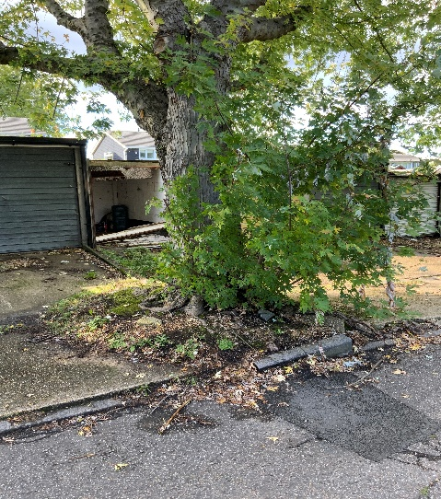
An example of where a large tree species is located in an unsuitable environment where it
has caused damage to the highway and adjacent infrastructure
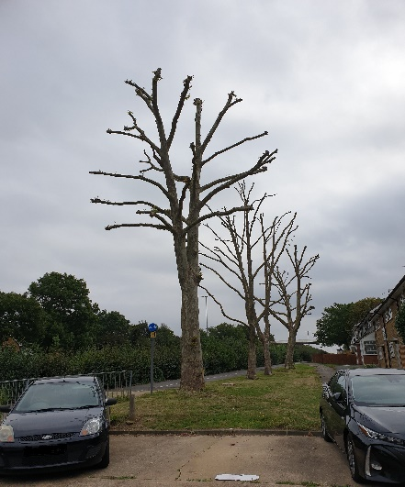
An example of where cyclical maintenance is carried out to reduce the likelihood
of damage to adjacent properties

STATEMENT IN1: The Council will investigate tree related claims but will only agree to tree works where a tree has been implicated.

STATEMENT IN2: The Council will endeavour to retain trees where possible. If pruning is a suitable method of management, the trees will be recorded on the tree management system and repeat works scheduled.

STATEMENT IN3: Where trees are identified as part of proactive surveys as being at risk of causing future damage, investigations will be carried out to identify whether damage may be foreseeable. Where it is deemed that they are likely to cause damage, appropriate work will be carried out commensurate with the risk posed.

2.3 Pest and disease tree management statements

Risks are posed to the Council’s tree stock because of incumbent pests and diseases (P&D). Whilst recognised pests and diseases present a known risk, there are a number of threats that are unknown and are not currently in the UK at present.

The Forestry Commission is leading the research into potential threats and provides regular updates on both threats already in the country and those that have the potential to have devastating consequences should they reach the UK. The risk for each P&D is different. In some cases, they cause mortality and failure, causing a safety risk on trees with high targets. In other cases, the biggest risk is to human health, where there is the potential for contact between humans and the pests. For other P&D, no action is needed as the damage that occurs is not sufficient to damage tree health.

The Council will responsibly manage all threats to and caused by its tree stock. This will be driven by industry best guidance in relation to specific P&D. The best practice is prone to change as threats spread and so the Council will ensure it is up to date on the most recent and relevant guidance.

Where a pest or disease is notifiable and is noticed as part of a survey or routine inspection, the officer will record the details on TreeAlert (https://www.forestresearch.gov.uk/tools-and-resources/fthr/tree-alert/) and on the tree management system if the tree is likely to need repeat inspection/maintenance as a result.
STATEMENTS PD1: The Council will remain up to date on incumbent pests and diseases that pose a threat to its tree stock and the public. It will practice good management of affected trees and will follow best practice guidance issued by the Forestry Commission.

STATEMENTS PD2: Any notifiable pests and diseases will be reported to TreeAlert and where necessary, recorded on the tree management system.

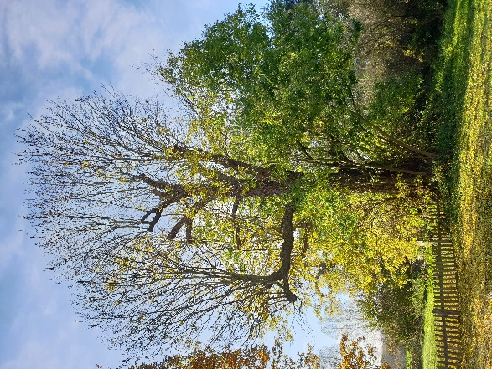
Ash tree in decline due to Ash Dieback

3. Highways and Built Estate Tree Management Statements
This section covers Highways, Schools, and the Built estate (Essex Property and Facilities). Whilst Highway also include large areas of rural roads, it rarely includes the hedgerow trees adjacent to/bounding the road. In urban areas, the verges and public realm are predominantly owned/controlled by Highways as are all the trees therein. Schools and the ECC Built estate are predominantly in urban areas.

3.1 Highway tree management statements

3.1.1 Highway Responsibilities
In a highway environment, the maintenance and care of the trees that grow in the highway is generally the responsibility of the Council. Trees growing on land adjacent to the highway or on the boundary are the responsibility of the adjacent landowner and for the purposes of this document will be referred to as private trees. Some trees within the highway will be subject to consents to the adjacent owner, local parish or district council and will commonly contain a requirement that they remain the responsibility of that person who will maintain public liability insurance for any damage that may be caused. These are also viewed as private trees.

The districts and boroughs that the Council is directly responsible for the maintenance of highway trees are:

- Braintree
- Brentwood
- Castle Point
- Chelmsford
- Maldon
- Rochford
- Uttlesford

Some districts deliver tree management on behalf of the Council under existing arrangements. Our requirements will be discussed with them to ensure a consistent approach in accordance with this plan. These districts/boroughs are as follows:

- Basildon
- Colchester
- Epping
- Harlow
- Tendring

Thurrock and Southend are unitary authorities outside the administrative boundary of the Council and are responsible for the maintenance of their highway trees.

Where the Council’s trees require periodic management to ensure the safety of highway users (vehicles, cyclists and pedestrians), maintenance works will be prioritised, based on the growth characteristics of the trees, their location, the need for maintenance and in line with the budget available. For example, quick growing trees along a school bus route are likely to need more frequent maintenance than the same trees growing along a wide urban street with infrequent use by high sided vehicles.

Generally, the inspections will be carried out in line with the General Tree Management Statements unless a different inspection routine is outlined in the Highway Tree Management Statements. These statements refer to trees that are located within the publicly maintainable highway, and for which the Council, as local highway authority, has a direct responsibility for, or are the responsibility of the Council due to being located on land owned by Highways, unless (in either case) specified otherwise.

3.1.2 Reactive inspections
Whilst proactive surveys will be carried out in accordance with the General Tree Management Statements, reactive inspections on the highway will still be undertaken. These will likely result from emergencies, such as tree failure over the road, or may be in response to general enquiries from the public, other authorities or from within the Council.

If a recent inspection has been undertaken and there are unlikely to have been any significant changes to the condition of the tree, then an inspection may not be undertaken. If the condition of the tree is likely to have changed or if there is concern over the structural integrity of the tree, a subsequent visit will be undertaken.

3.1.3 Commercial bus routes
As local highway authority, the Council has responsibility for managing highway trees along commercial bus routes. Where appropriate and where they are reported, Council staff will inspect and identify the extent of the work. To facilitate the inspection, the Council will require detailed information regarding the extent of the site and a sufficient location map. Work will be typically carried out between October and March annually, when the trees are dormant. The timing also allows for long stretches of highway vegetation to be flailed/crown lifted, which if carried out during the summer months could be restricted by nesting birds. If work is carried out during the winter, it is less likely to be carried out as scheduled without the need for nesting checks.

Where the trees causing an obstruction to the commercial bus route do not belong to the Council, depending on the priority of the work, it will either follow the process of a private tree or work may be undertaken by the Council in the interests of expediency. This follows the precedent set by Lemon v Webb (1985). All details as to the reason the Council undertook the work instead of the tree owner will be recorded on the tree management system.
STATEMENT HW1: Where practicable, the Council will aim to keep commercial bus routes unobstructed. The work will most likely be undertaken during the winter months to prevent disruption to nesting birds.

3.1.4 Clearance from the Highway
Trees may be pruned to ensure unobstructed passage for pedestrians and other highway users in the footway and over the carriageway in accordance with the Highways Act 1980 and as set by the highway authority. Whilst the whole extent of the highway should be free of obstructions, the minimum width clearance proposed will allow passage for two pedestrians., However, in some places, this might be reduced to a minimum of 1.2 metres where there are physical constraints. A minimum height clearance of 2.5 metres will be observed over footpaths and 5.2 metres will be observed over the carriageway (Essex Design Guide, 2018). Lamp columns and other street furniture require a clearance to prevent obstruction/damage.

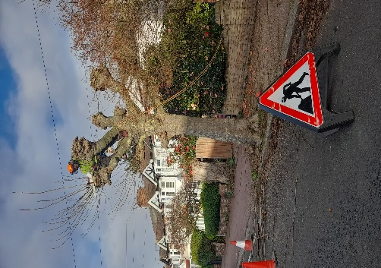
Pollarding works being carried out to a highway tree
STATEMENT HW2: Where practicable, the Council will aim to keep an unobstructed right of way for pedestrians and other highway users to the minimum widths set out by the highway authority and to a minimum height of 2.5 metres over the footway and 5.2 metres over the carriageway.

STATEMENT HW3: Where practicable, the Council will aim to carry out pruning to clear all publicly maintainable lamp columns, signage, and other highway furniture where the tree causes an obstruction or damage.

3.1.5 Private trees
Where private trees overhang a highway so as to endanger or obstruct the free passage of users or obstructs or interferes with the view of drivers of vehicles, or the light from a public lamp, the Council has the right to issue a notice under section 154 Highways Act 1980 to require the landowner to carry out works. Cases will be assessed against the Highway Authority Enforcement Policy which favours liaison with landowners in the first instance, but enforcement notices may be served where it is not possible to reach a resolution.

If the notice is not complied with, the Highway Authority has the right to carry out the work in default and look to recover the costs of doing so from the person upon whom the notice was served.

3.1.6 Utilities and overhead cables
The cutting back of trees from overhead cables is the responsibility of the utility company.

Where the installation or maintenance of underground services is concerned, the utility company is required under the New Roads and Street Works Act 1991 (NRSWA) to obtain a permit/book the road space from the Council in order to carry out the proposed works, details of which are provided on the Council’s website via the following link: https://www.essexhighways.org/applications/road-opening-notice. It is the responsibility of the utility company to seek their own professional advice if roots are likely to be affected by proposed works. The specification for reinstatement of openings in the highway must be followed when a permit has been obtained. The specification is updated from time to time via the Council’s Highways website.

Various codes of practice under the NRSWA and guidelines issued by the National Joint Utilities Group (NJUG) contain advice on the working practices to be adopted when working near trees and the utility companies are expected to comply with the minimum recommendations in Volume 4 guidelines (NJUG, 2007).

The NRSWA, together with other legislation and guidance, makes provision for the utility companies to mitigate for damage or loss suffered as a direct result of their street works.

Where appropriate, ECC will liaise with the utility companies to ensure they comply with relevant codes of practice and guidance notes when working near trees. Planned work where trees are present normally warrant a pre-commencement site meeting to determine a set method of working, including what plant type might be acceptable.

Where damage occurs to trees as a result of utility company works, the Council will require the utility company to undertake or fund remedial tree surgery or replacement replanting.

If a tree is deemed to be unsafe and must be removed as a result of utility works, the CAVAT value assessment will be carried out by a Council Arboricultural officer and the value sought from the utility provider. This value will be used to plant new trees in the local environment to compensate for the loss.

Where the damage can be rectified and the tree safely retained with the use of pruning works, the Council will either provide the utility company with a specification and require them to arrange the work (using an approved contractor) or carry out the works and recharge the cost of the works where possible. The decision will be based on whether the utility company is in agreement about the expediency of the work. This process will ensure that, where possible, trees are retained but the financial burden is placed on the utility provider to rectify their mistake.
STATEMENT HW4: The Council will not cut trees back from overhead cables as this is the responsibility of the relevant utility company.

STATEMENT HW5: Where damage occurs to trees because of utility works, or other licensed works, either through trenching or above ground works, the Council will require the utility company to undertake or fund tree surgery/replacement planting.

3.1.7 Vehicle crossovers
Under S184 of the Highways Act (1980) any person can request the construction of a crossing over the footway/verge (Crossover). Working within the root protection area of a highway tree, or the necessary removal of a highway tree to facilitate a crossover, is a separate consent that is required in addition to the consent to construct a vehicle crossover and therefore will require pre-application advice from the Arboricultural team.

Work is underway to clarify the process to applicants. Although a crossover request can be made without pre-application advice, it is suggested that applicants request advice from the Arboricultural team in advance of their application being submitted to Essex Highways where the proposed crossover is within 15m of a highway tree. Full details on the process will be set out on the website.

The pre-application advice will advise on whether the highway tree is suitable for removal or replacement and whether the applicant is likely to succeed with their crossover application in relation to trees. One of the following outcomes is likely:

- The applicant can proceed with the crossover application without any additional requirement in relation to trees.
- The applicant can proceed with the crossover application, subject to committing to working to methods specified in their advice to prevent damage to a highway tree.
- The applicant can proceed with the crossover application but will be required to provide funds for tree removal and replacement prior to crossover approval.
- The applicant should not proceed with the crossover application as the tree is considered to be of sufficient quality (maturity, importance etc) that mitigation for its loss cannot be provided.

If the applicant receives advice not to proceed with the crossover application but chooses to apply, the Highways Act (Schedule 14) states the Highway Authority has 8 grounds for objecting, including, “that the proposed works are unreasonable in character or extent or are unnecessary”. The Council views the removal of street trees as “unreasonable in character”, effectively downgrading the landscape and amenity of the road, and therefore may refuse the crossover application.
STATEMENT HW6: The council will review each application for vehicle crossovers within 15m of a Highway tree and provide advice on whether a crossover application in the vicinity is suitable, subject to pre-application fees. Any application submitted against advice will be subject to review in line with the Highways Act (1980).

STATEMENT HW7: Where tree removal is necessary and approved, the applicant will be liable for the cost of replacement planting, payable at the time of crossover approval, to carry out replacement planting.

3.1.8 Tree planting
Future tree planting in the highway will follow a different process to other areas of the Council’s sites. The Essex Green Infrastructure Strategy (2021) set out numerous green Infrastructure ambitions and targets, including tree planting. In 2019 the Council set up the Essex Forest Initiative (EFI) target, a five year plan to plant 375,000 trees ( https://www.essex.gov.uk/the-essex-forest-initiative) . EFI has raised over £1.1 million over the last 2 years, the majority of which was for Highway planting. Future new or replacement planting will be subject to budget availability and further fund raising.

Where trees are removed on the highway, the site will be assessed for suitability to support a new tree. If a tree has been recorded due to an insurance claim, it is unlikely that the location would be suitable for a new tree to be planted, and therefore a replacement would not be appropriate. When a tree is removed to protect people and/or property from foreseeable failure/damage, the same assessment will be made, based on whether there is any visible damage to nearby infrastructure and whether the verge is large enough to support a new tree long term. Again, if the location is not suitable, it will be noted on the tree management system. Where replacement is suitable, the location will be marked on the tree management system with recommendations on appropriate species. The replacement will be the responsibility of the EFI team, who will endeavour to plant in the next available planting season (November to March inclusive).

As part of the existing proactive surveying system in operation on the highway network, new planting locations will be identified. These will be marked on the tree management system as potential locations with recommended species, which will be guided by the Tree and Design Action Group’s Tree Species Selection for Green Infrastructure: A Guide for Specifiers (Tree Species Selection for Green Infrastructure - Trees and Design Action Group (tdag.org.uk)). Subject to relevant services and utility (STATs) checks, and funding streams, planting will be carried out on the first planting season after funding is available (November to March inclusive). Those locations where STATs checks have been carried out which confirm that planting is not suitable will be recorded on the tree management system as unsuitable. This proactive surveying system will create a definite record of areas that can be planted and those that cannot.

As well as the Council’s own powers to plant within the public maintainable highway under s96 of the Highways Act 1980, local authorities (district/borough/city/parish) may, with be authorised by the Council to plant. Any planting under this section must not inhibit the use of the public highway and is formalised by a consent process which requires the local authority to have suitable third-party liability insurance for any damage caused, which could include adjacent properties.

Under section 142 of the Highways Act 1980, the highway authority for a highway may by a licence granted under this section permit the occupier or the owner of any premises adjoining the highway to plant and maintain, or to retain and maintain, trees, shrubs, plants, or grass in such part of the highway as may be specified in the licence. A licence can be terminated on notice where it is necessary for the purpose of the exercise of their functions as a highway authority. As part of the application to the network assurance team, details of the location and the proposed species will be required from the applicant. The information provided will be reviewed by the Arboricultural team for appropriateness. If the location is unsuitable to support a tree, or if future highway improvements are planned affecting the verge, the application will be refused, or, if appropriate, an alternative species may be suggested. Where the proposal is considered to be suitable, the relevant legal documentation (which specifies the permitted planting, planting area and requires the applicant to cover liability indemnity, maintenance etc) will be required to be signed by the owner/occupier before planting can be carried out. The licence to plant will then be granted to the resident.

Requests for new highway trees are welcomed, however, as with all highway planting, the locations, and species of these trees will be decided on based on the suitability of the local environment, budget availability and priority. Where these requests are made, they will be noted on the tree management system for further investigation. There is no guarantee that a tree will be planted subsequent to a request, but the enquiry will be considered by the Council.

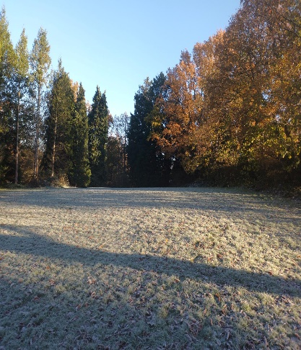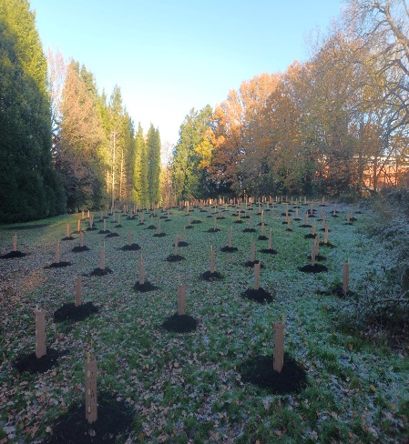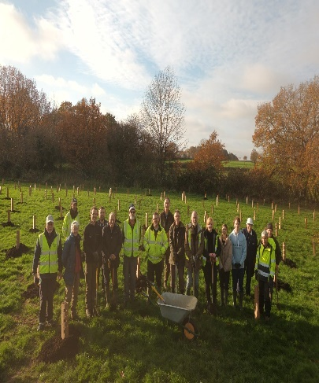
Before Planting After Planting Tree Planting in Basildon
STATEMENT HW8: The Council will endeavour to replant trees removed from the highway, however, where locations are not suitable to support a tree, this will not be done.

STATEMENT HW9: As part of the proactive surveys of highways, locations for potential planting may be identified. Subject to STATs checks and funding streams, these will be planted in the next available planting season (November to March inclusive).

STATEMENT HW10: Applications for licence to plant (s96 and s142 of the Highways Act 1980) will be considered on a case-by-case basis and will be subject to a suitable planting location/species.

STATEMENT HW11: Requests for planting will be considered and recorded on the tree management system. Suitable locations will be planted in the next planting season (November to March inclusive) if budget allows. Locations identified as unsuitable will be recorded in a similar manner.

3.1.9 Trees on new developments
Essex Highways may choose to take on as highway trees, trees located within grass verges on new developments, subject to the correct Development Management technical approvals and funding to secure their long-term maintenance, and this will be subject to any separate details as contained within the ECC Developers Guide to Infrastructure Contributions. As with the processes for determining suitability for planting locations, the plans supplied as part of the planning consent will be considered in relation to the local environment. As set out in the general statements above, the Council will not adopt trees that would likely pose a future risk of damage to the highway network, cause damage to adjacent properties or that will increase the burden on maintenance budgets. Any plans will be reviewed and approved by the Arboricultural team, in consultation with the Development Management team, who can arrange for any changes to be made to species selection and/or pit design at some stage prior to adoption.

If highway trees are required for removal to facilitate a development, the permission is required from Essex Highways in conjunction with advice from the Arboricultural team. The Council will work with the developer/applicant to request the landscape designs be amended to accommodate important trees. If this is not possible, compensation will be sought under a s106 agreement. This will mitigate the loss of the tree and provide for replacement planting locally. The value of this compensation will be in line with the CAVAT value of the tree to be removed and the cost of aftercare of new planting.

If any Highway tree is to be retained within 15 metres of a new development, suitable working methods must be employed to prevent any damage. These must be in line with British Standard 5837:2012.

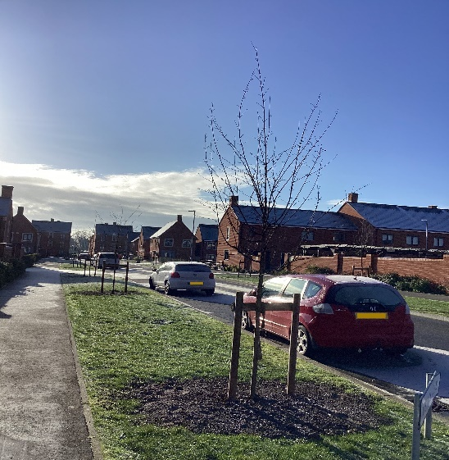
Trees planted as part of a new development in Colchester

STATEMENT HW12: The Council is not obliged to adopt any trees a developer proposes on the proposed adopted highway and will assess all proposed schemes on an individual basis.

STATEMENT HW13: The Council will not adopt as highway trees any that would be likely to cause future damage to grey infrastructure or adjacent properties. They will discuss alternatives with the developer prior to the proposed road adoption.

STATEMENT HW14: Permission must be sought from the Council if a highway tree requires removal as part of a development. If permission is granted, the CAVAT value of that tree will be sought from the developer to fund planting in the local Highway network.

STATEMENT HW15: Working methods in line with British Standard 5837:2012 must be employed by developers when working withing 15 metres of any retained highways tree.

3.2 School tree management statements
In April 2022 the Department for Education in its Sustainability and Climate Change strategy declared that all school ground contributed to the National Educational Nature Park, setting a strong environmental agenda for all school grounds and their existing and potential tree populations. The surveying for all school sites (excluding schools that have become academies) will be undertaken in line with the general management statements in this document and the existing Service Level Agreement. All schools that have moved to academy status will be responsible for arranging their own tree inspections.

The resulting survey reports will be passed to the individual school who will be responsible for arranging and paying for recommended works. The Arboricultural team will be able to provide a list of suitably qualified contractors at the request of a school.

Where a school is concerned about the safety of a tree in between inspections, it can arrange a reactive inspection with the Arboricultural team. These reactive inspections will not generally change the date of the next full site inspection although, where a school is due a whole site inspection within six months, this may be bought forward and recorded on the tree management system.

STATEMENT SCH1: The Council will endeavour to carry out inspections of schools it is responsible for every three years, but it is the responsibility of each individual school to arrange tree works in line with recommended timescales.

3.3 Essex Properties and Facilities (EPF) tree management statements
ECC also own a substantial estate of buildings including ECC Offices, Libraries, Adult Community Learning Centres, Nurseries and Youth centres. These buildings are generally set in urban areas and around these buildings are car parks, landscape, and substantial tree numbers. These buildings and surrounding areas are the responsibility of EPF, which contract Mitie to carry out its services. The inspection processes will follow the general tree management statements outlined earlier in this document.

Not all works can be undertaken immediately after the inspection has been carried out. The inspection report will be sent to Mitie/EPF outlining all recommended works for a site, at which point, a request will be made back to the Arboricultural team to obtain quotes for the highest priority works. The highest priority is those at the highest risk of failure.

Once quotes have been obtained, a contractor will be instructed in the same manner as the general tree management statements and the tree management system updated accordingly.

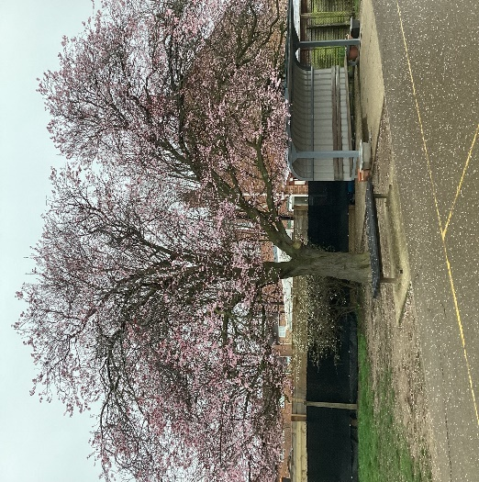
A tree located on an Essex Properties and Facilities site where the tree is
an important feature in the local amenity

4. Rural Estate Tree Management Statements
This section covers the rural estate of Essex County Council covering Country Parks, ECC Woods, the rural estate and the EFI woodlands.

4.1 Country Park tree management statements

Whilst the inspection regimes will be in line with the General Management Policies, there are some specific management policies that will solely related to the Country Parks within the ownership of the Council.
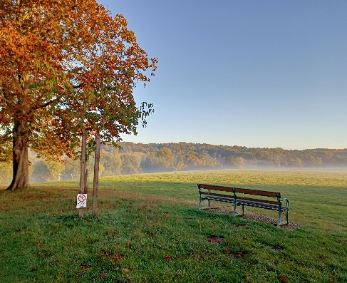Trees are an essential element of the historic designed landscape at Weald Country Park

4.1.1 Retention of deadwood
Given that woodland sites are heavily shaded, there is likely to be a much higher volume of deadwood (in the form of dead branches within the canopy) than would be found on trees in open spaces. Deadwood provides good habitat for bats, birds and invertebrates and is an essential part of woodland habitat and the benefits of natural deadwood generally outweigh those of artificially created features. The risk of people being injured by deadwood is generally low, however, during inspections the risk from deadwood will be assessed. Where the risk is low, deadwood may be retained over low use paths in the Country Parks. In rarely used areas all deadwood will be retained in line with good woodland management.

There may be instances, for example where veteran trees are present, where it may be more appropriate to exclude access below the deadwood rather than removing it. Where alternatives to tree surgery are available, these will be used in favour of retaining deadwood where it is beneficial to the tree and the local habitats.

Standing deadwood (dead trees that remain upright) will similarly be retained wherever it is possible to do so without creating a risk to visitors. Deadwood lying on the ground will always be retained.
STATEMENT CP1: In line with good woodland management, deadwood in Country Parks will be retained where possible. Where the deadwood poses a risk works may be recommended for its removal.

4.1.2 Veteran trees
Veteran trees are highly valuable heritage and ecological assets in the Country Park sites as, not only do they have historical context within the sites, but also constitute irreplaceable habitat. Weald, Thorndon, Danbury, and Belhus Woods Country Park are all registered historic Parks and Gardens and contain fine populations of veteran trees. Their protection is paramount and so their management must be considered in relation to the context of the site use.

The Council is currently undertaking surveys on all veteran trees located within Country Parks; however, these will be phased and will be carried out as budget is available. Once this database of trees is created, it will allow for long term management to be programmed and ensure that the surrounding woodland is managed whilst considering the best interests of the veteran trees. The management will be done in line with industry guidance, namely ‘Veteran Trees: A guide to good management’ (2000), which highlights the following issues in relation to damage to trees:

Intentionally by:
- burning through intended fires or accidental ones
- vandalism, for example damaging trees or their bark, or graffiti

Unintentionally by:
- climbing on trees, which damages the bark, so the tree is unable to transport food and water efficiently
- trampling around trees, which can in extreme cases compact the soil affecting water uptake and mycorrhizal fungi
- collecting of specimens
- removal of deadwood
- car parking (causing compaction); and
- marking trees with waymarks for trails

It also goes on to highlight some of the ways these issues can be resolved or mitigated

- inform the public about the value of these trees through signs, leaflets, guidebooks, guided walks, and nature trails
- fence the trees to reduce compaction etc. This is not a recommended solution but may be necessary for key feature trees
- to locate car parks to open areas and/or use shrubs for shade and screening and outside of the protection areas of future veteran trees
- discourage access right up to trees where there is a specific problem, e.g. By using dead hedging (especially prickly plants); and
- erect raised walkways around key feature

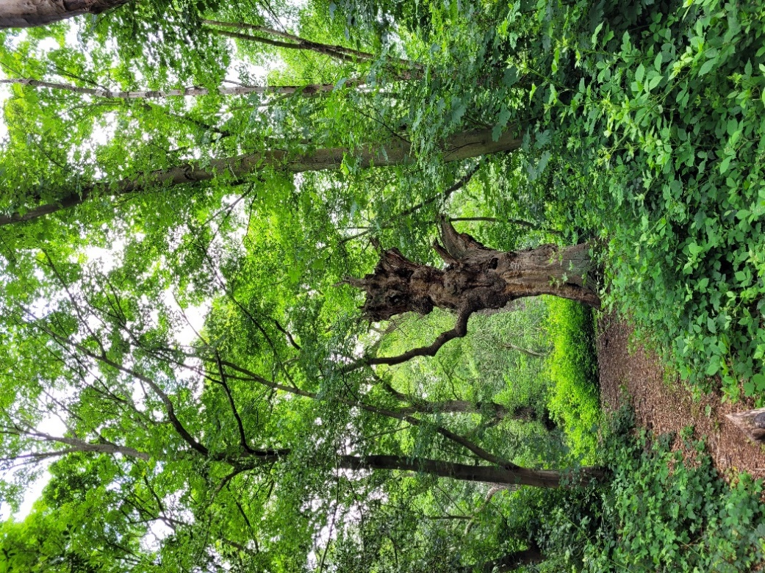
An example of a veteran tree located at Danbury Country Park
STATEMENT CP2: The Council will manage its Country Park veteran tree stock to the best of its ability in line with best practice guidance.

4.1.3 Woodland management
The Country Parks contain a considerable area of woodlands, especially in the historic parks of Weald, Thorndon, and Danbury Country Parks. In addition, ECC owns 130 hectares of woods found in the wider countryside across the County. Many are very important and rare ancient woodlands. Generally, the principles of ECC’s ‘Woodland Management Plan’ will be used in relation to the woodland areas of Country Parks and the ECC Woodlands. The objectives of the management plan are:

- to maintain healthy and diverse woodlands which are resilient to climate change and make a positive contribution to carbon sequestration
- to maintain and improve habitat for biodiversity
- to enable public access via public and permissive footpaths
- for management to be at least cost neutral in the short and medium term; and
- to manage sympathetically woodlands with high cultural or heritage value and reveal and communicate their importance to woodland visitors

Where possible, additional funding streams will be sought. This includes Countryside Stewardship, Biodiversity New Gain and Highways England designated Funds, which will aid in providing good woodland management.
STATEMENT CP3: The Council will endeavour to manage its Country Park woodlands and rural woodlands in line with best practice and in line with [its] ‘Woodland Management Plan’.

4.2 New Woodlands

The Essex Forest Initiative (EFI) began planting woodlands in 2020 and has a five-year plan to plant 375,000 trees. Climate Action work in ECC has increased since the publication of the £200m four-year Climate Action Plan in 2021 (which endorsed the Essex Climate Action Commission’s Net Zero: Making Essex Carbon Neutral report). These new woodlands will be inspected annually by the EFI team as part of the establishment regime checking on the health of the new trees.

After three years, the trees themselves are unlikely to be large enough in size to constitute a health and safety risk. However, if these trees are planted on land that is publicly accessible and where there are established trees on adjacent land that are within falling distance of the publicly accessible areas, then site surveys will be carried out in line with the general management statements.

Where an EFI officer is concerned about the safety of a tree in between inspections, they can arrange a reactive inspection with the Arboricultural team. These reactive inspections will not generally change the date of the next full site inspection although, where a site is due an inspection within six months, this may be bought forward and recorded on the tree management system.

4.3 The Rural Estate
ECC owns 412 hectares of farmed estate scattered across the County and sometimes in adjacent authorities. Most site are tenanted or rented to farmers or land managers and the inspection of tree stock is dependent on the responsibilities set out in the site leases. Where ECC retain liability for tree safety, inspections are carried out in line with the EPF Tree Management Statements.

Although most Public Rights of Way are in private ownership, where tree hazards are identified by the Public Rights of Way team. When they report the tree hazard it leads to this leads to reactive Inspections (see 2.1.1 above).

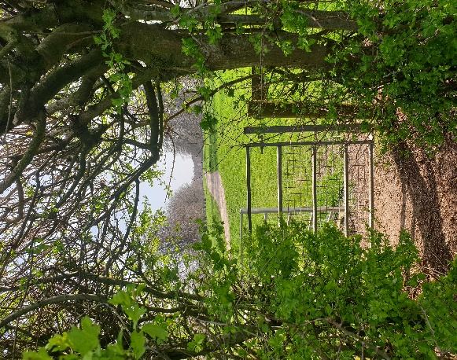
An example of a public right of way running through a hedge in Danbury

- Glossary
CAVAT (LTOA, 2008) means the Capital Asset Value for Amenity Trees. It provides a basis for valuing trees as an asset rather than as a liability and can be used as an assessment tool for the cost of replacing trees when their removal is essential. More information can be found here: https://www.ltoa.org.uk/resources/cavat

Crown lift means to remove the lowest branches to a given height and/or preparing of lower branches for future removal.

Crown reduction means removal of a specified amount of the canopy, either for a volume reduction, to rebalance the crown or maintain a tree for a structural defect.

Crown thin means to remove a portion of the smaller/tertiary branches in the outer crown to reduce the density of a crown. It is not appropriate for all species as it can lead to more dense canopies once regrowth has occurred.

Cyclical maintenance means to carry out repeat works to a tree (normally crown reduction/pollarding) on a regular cycle.

Deadwood is wood within the crown that no longer has live tissue. In some species, this wood can be retained for a long period of time, but in others it will drop much sooner. It can result from internal shading from other branches or can be an indication of ill health.

Defects are any injuries, growth patterns, decay or other conditions that reduces the tree’s physiological strength.

Essex Forest Initiative (EFI) is a project managed by the Climate and Adaptation team within Essex County Council, responsible for obtaining funding for and planting of 375,000 new trees over five years.

Ezytreev© is the chosen tree management software that the Council will use to record all tree inspections and management.

Fell means to remove a tree in its entirety.

LANTRA are an awarding body associated with Arboricultural qualifications.

Physiological condition means the overall condition of the tree and its ability to grow.

Pollard (and re-pollard) is to remove the upper branch structure of a tree, leaving predominantly stem in place to allow a dense mass of smaller branches.

Reduction works means to reduce the size or area of the canopy either to remove an obstruction or to manage a tree at a set size.

s106 agreement means a planning obligation under section 106 Town and Country Planning Act 1990.

Site (for site survey) means a named/identifiable piece of land under the ownership/responsibility of a directorate within Essex County Council that will have its own record of trees and will have its own reinspection regime, commensurate with the risk posed by the trees.

Structural condition means the ability of the stem/branch structure of the tree to be supportive of the weight/sail area of the tree.

Stump grinding means to mechanically remove the stump after felling.

TreeAlert is the Forestry Commission’s website for reporting notifiable pests and diseases. They require mapping, photographs, and information on the amount of infestation for each report. [https://www.forestresearch.gov.uk/tools-and-resources/fthr/tree-alert/]

- Legislation and Legal Cases
Lemmon v Webb (1894) is case law whereby a neighbour cut back overhanging branches without obtaining permission from the tree owner, provided he could do so from his own land. [https://www.bailii.org/uk/cases/UKHL/1894/1.html]

The Highways Act 1980 is the main legislation under which the local highway authority operates and includes the rights to carry out works on highway and non-highway land as well as duties including to maintain the highway and to protect the rights of the travelling public [https://www.legislation.gov.uk/ukpga/1980/66]

Wildlife and Countryside Act 1981 makes it an offence to damage or destroy all active bird nests (of any species), and to disturb some bird species (those on Schedule 1) at or near the nest site. The nests of species on Schedule 1 of the Act are protected at all times, whether active or not. The Act also makes it an offence to kill or injure some animal species, including all bat species and Dormouse. Contractors and those instructing them must take reasonable steps to determine the presence of active nests or protected species before starting work. In some cases, a licence may be required to legally permit work. [https://www.legislation.gov.uk/ukpga/1981/69]

Occupiers Liability Act 1984 places a responsibility on the owner of a property to keep all visitors safe from reasonable harm. [https://www.legislation.gov.uk/ukpga/1984/3]

Town and Country Planning Act 1990 specifically in relation to trees, sets out practices for protecting important trees and trees located within Conservation Areas. It places restrictions on carrying out work to such trees and sets out the exemptions in relation to work. [https://www.legislation.gov.uk/ukpga/1990/8/contents]

New Roads and Street Works Act 1991 (NRSWA) provides working requirements for undertaking work on the highway [https://www.legislation.gov.uk/ukpga/1991/22/contents]

Town and Country Planning (Tree Preservation) (England) Regulations 2012 sets out more detailed guidance on how Tree Preservation Orders (TPOs) should be made and maintained, as well as providing detail on exceptions and action that can be taken as a result of contraventions. [https://www.legislation.gov.uk/uksi/2012/605/contents/made]

Dillner v Sheffield City Council (2016) was a decision whereby residents requesting to prevent the felling of multiple street trees was refused on the basis that refusal would have led to the Council not being able to undertake their statutory duties. [https://www.judiciary.uk/wp-content/uploads/2016/04/dillner-v-scc-judgment.pdf]

Conservation of Habitats and Species Regulations 2017 includes protection from killing, injury and disturbance for European Protected Species, which include all bat species and Dormouse. The Regulations also protect the habitats of European Protected Species (such as bat roosts) from damage or destruction, whether occupied at the time or not. Contractors and those instructing them must take reasonable steps to determine the presence of active nests or protected species before starting work. In some cases, a licence may be required to legally permit work. [https://www.legislation.gov.uk/uksi/2017/1012/contents/made]

Cavanagh v Witley Parish Council (2018) was a case where it was found than an inspection regime of three yearly was insufficient if a tree was a mature and in a high target area. It was deemed that the timescale between inspections should be commensurate with the risk posed by the tree. [https://ntsgroup.org.uk/123-2/]

Environment Act 2021 is legislation that puts a requirement on the inclusion on Biodiversity Net Gain in new developments, but also places a duty on the local authority to consult on the felling of street trees (unless exempt). [https://www.legislation.gov.uk/ukpga/2021/30/contents/enacted]

- Guidance and References
British Standard 3998: 2010 Tree Work. Recommendations (BSI, 2010) is industry guidance on how to carry out tree work. [https://knowledge.bsigroup.com/products/tree-work-recommendations/standard]

British Standard 5837: 2012 Trees in relation to design, demolition and construction is guidance on how to survey and retain trees as part of new developments. [https://knowledge.bsigroup.com/products/trees-in-relation-to-design-demolition-and-construction-recommendations/standard]

Essex Climate Action Plan was published in November 2021 by Essex County Council. [https://assets.ctfassets.net/knkzaf64jx5x/4Ihrw6uXe2g19YxYWkfsk6/eba8f76776738b010f21d3e7f3b9add2/9422_Climate_Action_Plan_Report_v3_-_Digital_Accessible.pdf]
Essex County Council Developers Guide to Infrastructure Contributions. (2019) https://assets.ctfassets.net/knkzaf64jx5x/5aKhke88Ey5zkdMvSQj44w/0d71817cad70b9394d76e7a490ac7bd7/developers-guide-infrastructure-contributions.pdf

Essex Design Guide (2018) is local guidance that outlines good practice for developers in terms of building design, architecture, and Green Infrastructure standards. [https://www.essexdesignguide.co.uk/]

Essex Green Infrastructure Strategy (2021) outlines how the Council aims to deliver high-quality green infrastructure and green spaces across Essex. [https://www.placeservices.co.uk/resources/built-environment/essex-gi-strategy/]

Everyone’s Essex: our plan for levelling up the county – 2021 to 2025 (2021) by Essex County Council. [https://assets.ctfassets.net/knkzaf64jx5x/QfCTFvZFWm6jBFzKIcxU8/3033e555110ddb553603919ae00c638d/ECC-Everyones-Essex-plan-2021-to-2025.pdf]

Mitigation guidance to protect bats and their roosts during Arboricultural operations, Natural England 2010 is a guidance document outlining how to carry out tree work alongside known bat roosts and gives guidance on emergency tree work. [https://www.trees.org.uk/Trees.org.uk/files/e4/e4bdca92-c9a0-44bd-9af2-f4a300424bbf.pdf]

National Joint Utilities Group (NJUG) Volume 4 gives guidance to utility undertakers on how to work around trees/tree roots. [http://streetworks.org.uk/wp-content/uploads/V4-Trees-Issue-2-16-11-2007.pdf]

National Tree Safety Group’s ‘Common sense risk management of trees’ 2011 is industry guidance that sets out how and when inspections should be carried out, and how there must be balance between risk and tree health. [https://ntsgroup.org.uk/wp-content/uploads/2016/06/FCMS024.pdf]

Net Zero: Making Essex Carbon Neutral Report was published in July 2021 by the Essex Climate Action Commission. Net Zero: Making Essex Carbon Neutral report (PDF, 5.33MB)

Tree and Design Action Group’s Tree Species Selection for Green Infrastructure: A Guide for Specifiers is recent industry guidance outlining optimal locations for tree species. It is updated regularly and gives proper guidance for the ‘Right tree, right place’ principle. [Tree Species Selection for Green Infrastructure - Trees and Design Action Group (tdag.org.uk)]

Veteran Trees: A guide to good management (2000) provides industry guidance on sensitively managing veteran trees. [http://publications.naturalengland.org.uk/publication/75035]

Woodland Management Plans are written for each of the ECC woodlands managed under Countryside Stewardship. Although these are not publicly available, they are kept on file and amended as necessary.

This information is issued by:
Essex County Council
Contact us:
Arboriculture@essex.gov.uk
Place Services
Essex County Council
County Hall, Chelmsford
Essex, CM1 1QH
Essex_CC
facebook.com/essexcountycouncil
The information contained in this document can be translated, and/or made available in alternative formats, on request.
Published September 2023

